LAB # 02
OBJECTIVE
Flow of Control in C#
Maths Function in C#

Introduction
The term flow of control refers to the flow of execution through your program. By default,
Program execution moves sequentially from one statement to the next. The control statements allow you to modify the order of execution.
Selection statements: These statements allow you to select which statement, or block of statements, to execute.
- if: Conditional execution of a statement
- if...else: Conditional execution of one statement or another
- switch: Conditional execution of one statement from a set
Iteration statements: These statements allow you to loop, or iterate, on a block of statements.
- for: Loop—testing at the top.
- while: Loop—testing at the top.
- do: Loop—testing at the bottom.
- foreach: Execute once for each member of a set.
Jump statements: These statements allow you to jump from one place in the block or method to another.
- break: Exit the current loop.
- continue: Go to the bottom of the current loop.
- goto: Go to a named statement.
- return: Return execution to the calling method.

Selection Statements
In this section a class of statements is described which allow one or another block of code to be executed depending on some logical condition. These statements are extremely common and invaluable in programming

if Statement

This is a simple and intuitive construct
syntax 1
if ( condition )
true statement block;
else
false statement block;
syntax 2
if ( condition )
true statement block;

Example
int numerator, denominator;

Console.WriteLine(Enter two integer values for the numerator and denominator);
numerator = Convert.ToInt32(Console.ReadLine());
denominator = Convert.ToInt32(Console.ReadLine());

if (denominator != 0)
Console.WriteLine(“{0}/{1} = {2}”, numerator, denominator, numerator/denominator);
else
Console.WriteLine(Invalid operation cant divide by 0);

The statement body can include more than one statement but make sure they are group into a code block i.e. surrounded by curly braces.

Nested if else Statements
Nested if statements occur when one if statement is nested within another if statement.

Example
if (totalMarks >= 80)
{
Console.WriteLine ("Got Higher First Class ");
}
else if (totalMarks >= 60)
{
Console.WriteLine("Got First Class ");
}
else if (totalMarks >= 40)
{
Console.WriteLine ("Just pass only");
}
else
{
Console.WriteLine ("Failed");
}

Switch Statement
The C# switch statement allows you to choose from many statements based on multiple selections by passing control to one of the case statements within its body. This statement is similar to the if-else-if ladder but is clearer, easier to code and less error prone.

syntax:
switch( expression )
{
case constant1:
statement1;
break;
case constant2:
statement2;
break;
default:
default_statement;
}

Example
int val = 5;
switch (val)
{
case 1:
Console.WriteLine ("The day is - Sunday");
break;
case 2:
Console.WriteLine ("The day is - Monday");
break;
case 3:
Console.WriteLine ("The day is - Tuesday");
break;
case 4:
Console.WriteLine ("The day is - wednesday");
break;
case 5:
Console.WriteLine ("The day is - Thursday");
break;
default:
MessageBox.Show("Out of range !!");
break;
}

WHILE LOOP

While (expression)
{
Statements;
……….
}
more statements;

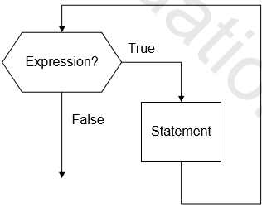

DO WHILE LOOP

- In the while loop, if the condition initially false, then the loop is skipped.
- If you want a loop in which the body is always executed, use a do/while.

do
{
…….
}
While ( expression);

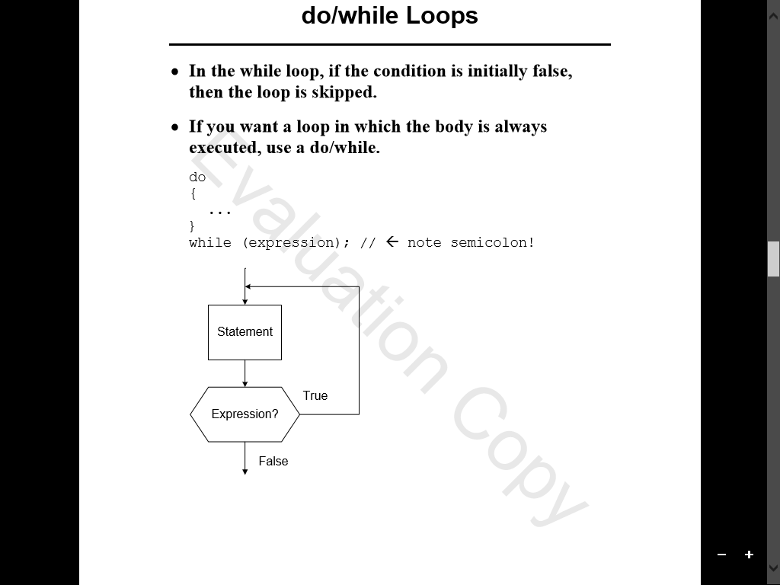

FOR LOOP

for( initialization; test; iteration)
{
Statements;
……….
}

More statements;

- The test must be Boolean expression. Initialization and iteration can be almost any kind of expression.

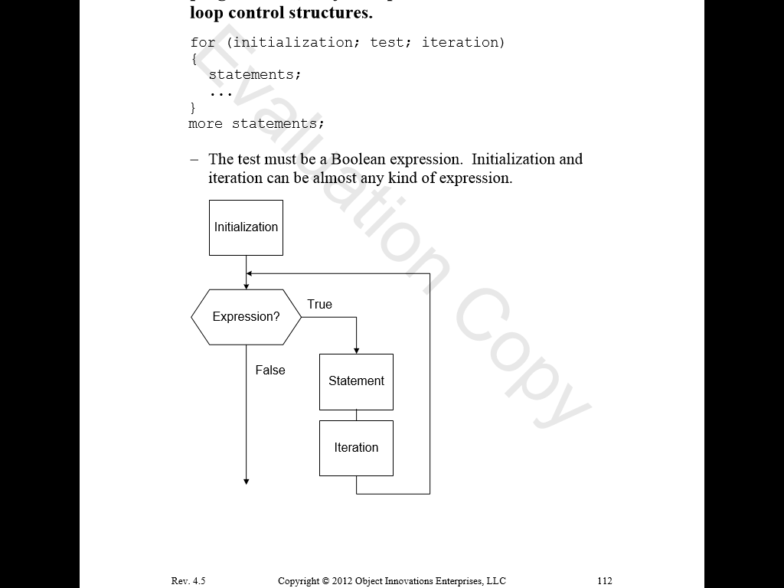

Maths Function in C#
Trignometric Functions

Using System;
class Program
{
static void Main()
{
Console.WriteLine(Math.Acos(0)); // Inverse cosine
Console.WriteLine(Math.Cos(2)); // Cosine
Console.WriteLine(Math.Cosh(5)); // Hyperbolic cosine

Console.WriteLine(Math.Asin(0.2)); // Inverse sine
Console.WriteLine(Math.Sin(2)); // Sine
Console.WriteLine(Math.Sinh(-5)); // Hyperbolic sine

Console.WriteLine(Math.Atan(-5)); // Inverse tangent
Console.WriteLine(Math.Tan(1)); // Tangent
Console.WriteLine(Math.Tanh(0.1)); // Hyperbolic tangent
}
}

Absolute Function

An absolute value is not negative. It is the same as the original value but with no negative sign. The Math.Abs method in the .NET Framework provides a tested absolute value function. It deals with certain edge cases.

using System;
class Program
{
static void Main()
{

int value1 = -1000; // Compute two absolute values.
int value2 = 20;
int abs1 = Math.Abs(value1);
int abs2 = Math.Abs(value2);
Console.WriteLine(value1);
Console.WriteLine(abs1);
Console.WriteLine(value2);
Console.WriteLine(abs2);
}
}
Power

Math.Pow computes exponential values. It takes the powers of numbers such as by squaring values. It is a simple and convenient way to compute exponents in the C# language

using system
public class Example
{
public static void Main()
{
double result = Math.pow(5, 2);
Console.WriteLine(result);
}
}

Logarithm

The Math class provides logarithms. With the Math.Log and Math.Log10 methods in the System namespace, we compute logarithms with a specific base or base 10.

using System;
class Program
{
static void Main()
{
double a = Math.Log(1);
Console.WriteLine(a);

double b = Math.Log10(1000);
Console.WriteLine(b);

double c = Math.Log(1000, 10);
Console.WriteLine(c);
}
}

Sqaure root

Math.Sqrt computes a square root value at runtime. A square root is the number that, when multiplied by itself, equals the original number. Sqrt is a slower computation. It can be cached for a performance boost.

using System;
class Program
{
static void Main()
{
// Compute square roots by calling Math.Sqrt.
double a = Math.Sqrt(1);
double b = Math.Sqrt(2);
double c = Math.Sqrt(3);
double d = Math.Sqrt(4);

Console.WriteLine(a);
Console.WriteLine(b);
Console.WriteLine(c);
Console.WriteLine(d);

}
}

Truncate
Math.Truncate eliminates numbers after the decimal. It acts upon a decimal or floating-point number. It calculate the integral part of a number.

using System;
class Program
{
static void Main()
{
decimal a = 1.223M;
double b = 2.913;

a = Math.Truncate(a);
b = Math.Truncate(b);

Console.WriteLine(a);
Console.WriteLine(b);
}
}

Constant
Math.E is a constant. It is a public float value. It stores the first digits of the base of the natural logarithm
using System;

class Program
{
static void Main()
{
double e = Math.E; // Get E constant
Console.WriteLine("--- Math.E ---");
Console.WriteLine(e); // Write E constant
}
}
Math.Exp computes values of the exponential function. To apply the exponential function, we either use Math.Pow to raise E to a specified power, or call Math.Exp with the exponent as an argument. Exp is part of the Math class.
using System;
class Program
{
static void Main()
{
// Compute e ^ 2.
double a = Math.Exp(2);
double b = Math.Pow(Math.E, 2);

// Write results.
Console.WriteLine(a);
Console.WriteLine(b);
}
}
Multiply
Math.BigMul multiplies two large integers. With regular multiplication, as with the star operator, the result may overflow. BigMul avoids this problem. It returns a long.

using System;
class Program
{
static void Main()
{
// Call BigMul.
long product1 = Math.BigMul(int.MaxValue, int.MaxValue);

// Display values.
Console.WriteLine(product1);

}
}
Division Remainder
Math.DivRem divides two numbers and returns the remainder. With the division operator we do not get the remainder in a separate variable. But with Math.DivRem we compute the quotient and the remainder. We can store them separately.
using System;

class Program
{
static void Main()
{
const int a = 1000;
const int b = 300;
int result;

int quotient = Math.DivRem(a, b, out result);

Console.WriteLine(quotient);
Console.WriteLine(result);
}
}
Task
Q1. With Menu Driven Program Design a Calculator having all the main functions also use Math’s functions.

Q2. Write a program to find that a letter is vowel or not using If-else statement?

Q3. Write a program that performs a survey on beveages. The program sholud prompt for the next person until a lookout value of -1 is entered to terminate the program. Each person participating in the survey should choose their favorite beverage from the following list?
- Cofee
- Tea
- Coke
- Orange Juice

Q4. Given an integer n such as 1367. Write a program that computes the inverse of this integer as 7631.

Q5. Write a program to print prime numbers within given range using while loop?

